Wright_Lab_Inventory

User Manual

Joe Baumgardt

Table of Contents

Main Menu Window 2

Drive ID Repair Window 3

Inventory Windows 4

Add to Inventory Window 6

Remove from Inventory Window 9

Entry Confirmation Window 12

Grid Dewar Inventory 13

-80 Freezer Inventory 15

-20 Freezer Inventory 17

Cell Culture Dewar Inventory 19

Executable 21

Potential Issues 21

# **Main Menu Window**

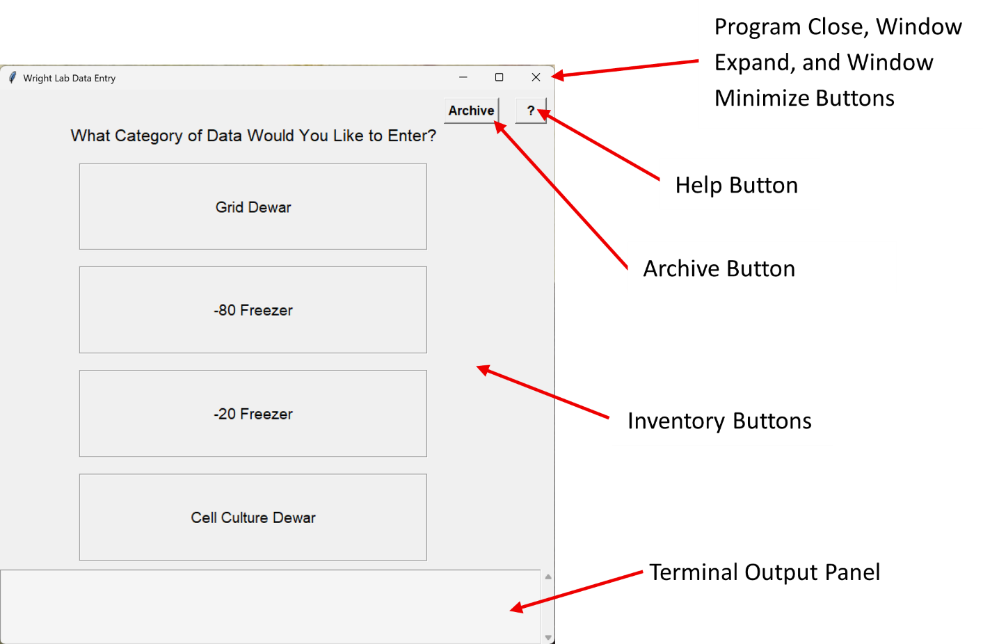

##### **Overview**

The main menu is opened when the program starts, and contains four different buttons: Grid Dewar, -80 Freezer, -20 Freezer, and Cell Culture Dewar. When you click each button, it takes you to the inventory window that corresponds to the respective inventory label.

##### **Program Close Button**

When clicked, it closes the program and deletes any temporary files.

##### **Window Expand Button**

When clicked, it expands the window to fill the screen.

##### **Window Minimize Button**

When clicked, it minimizes the program so it is no longer visible.

**Help Button**

Opens this Manual so you can get help on program use.

**Archive Button**

When clicked, the archive button will create a new folder within the Inventories folder where all inventory files are stored. This folder will be labeled Archive_MM_DD_YYYY, where MM_DD_YYYY is the current date. It will then save a copy of each inventory file to this folder, also ending with the current date.

It is important to note that if there is no archive folder for the current half-year (Ex: Jan-June or July-Dec) then the program will automatically make an archive folder. This was determined to be an adequate frequency of saving. This means it is only necessary to manually archive using this button if you are going to make major changes and would like to save a current version of inventory.

**Inventory Buttons**

Opens the corresponding inventory window to perform different actions on the stored inventory data. Upon opening one of these buttons, the program will attempt to download the file from Google Drive using the drive ID and API credentials. If it is your first time using the program, you will need to sign in to Google Drive. Once you have signed in, it will show the below message in the browser.



You can now go back to the program window and continue. After this, the program will save a token file that will save access to Google Drive and prevent further logins. See the Drive ID Repair Window to learn how to fix an incorrect ID. The API access will need to be set up before using the program by creating a credentials.json file. See the section on API access for more details.

##### **Terminal Output Panel**

At the bottom of the window, there is a separate panel that will contain any output written to the terminal. This allows you to see what the program is doing and identify potential errors that occur. The panel will only show output and can’t be used to interact with the program. This pseudo-terminal will be present in each subsequent window and maintain all output since the program opened. On the right-hand side, there is a scroll bar, and earlier output can be viewed using this scroll bar or your mouse's scroll wheel.

# **Drive ID Repair Window**

##### **Overview**

The Drive ID Repair Window only shows up when the program can not find a file with the Drive ID it currently has. The drive ID is a special code that identifies individual files within Google Drive. To find the Drive ID, go to the URL of your file on Google Drive and copy the area between “/d/” and the next “/”.



The most likely reason that a Drive ID has become broken is that someone has deleted the file on Google Drive and uploaded a new copy in its place. This window will permanently change your Drive ID and fix the issue locally, but it may be necessary for the drive_ids.json to be updated in GitHub for a more permanent fix for everyone.

If you delete a file and upload a new one in its place it is important to delete the old file from the trash bin as well, because the program will still fetch the file from the trash without giving any warning for other users who have not updated their Drive IDs.

##### **ID Variable Name**

This shows you the variable name that holds the broken Drive ID. The name of this variable will tell you which inventory you are not able to access.

##### **Current ID**

This shows what the program currently has as the Drive ID.

##### **New ID Entry Box**

This is where the updated ID can be entered.

**Update & Retry Button**

This will update the ID permanently in your program and restart the program.

# **Inventory Windows**

##### **Overview**

The inventory menu contains three buttons: View Current Inventory, Add to Inventory, and Remove from Inventory. The inventory window appears the same for all four inventory types. It may take a little bit of time for this window to open because the program first downloads the respective Excel sheet(s) from Google Drive and saves the data in a usable format.

##### **Back Button**

Every window (excluding the main menu) will contain a back button that allows you to go back to the previous window.

##### **View Current Inventory**

The “View Current Inventory” button opens the respective inventories Excel sheet(s) for easier viewing. It is important to close these Excel files before continuing because if they remain open, the program will be unable to write to and update it. If you attempt to Add/Remove inventory or go “Back”, a message will pop up prompting you to close open files before continuing. Close the files at this time and click “Retry” to continue or click “Cancel” to return to the current window.

##### **Add to Inventory Button**

The “Add to Inventory” button will take you to a new window where you can enter new inventory that has been added.

##### **Remove from Inventory Button**

The “Remove from Inventory” button will take you to a new window where you can remove inventory.

# **Add to Inventory Window**

##### **Overview**

The Add to Inventory window allows you to enter information about the inventory being added and update the Excel inventory sheet on Google Docs.

##### **Entry Field Labels**

These labels are the same as the columns of the respective Excel inventory sheet. A red asterisk is placed to the right of any field that must be entered before adding. In addition, any requirements for what can be entered in that field are given next to the label in parentheses. Below is an explanation of these requirements.

(integer)

* It must be an integer (whole number).

(format: A8, B1 Comma separated for multiple)

* This is indicative of the final position field.
* It must be a single letter followed by a number.
* Multiple units of inventory can be added by separating them with commas (Ex: A3, C13, F2)

(format: A8, P23)

* It must be a single letter followed by a number

(MM/DD/YYYY)

* This is the date column and the date must be entered in MM/DD/YYYY format

##### **Entry Boxes**

Each field in the form has an entry box where you can type in information for the inventory you are adding. When you click into an entry box, a drop-down menu will appear showing all the existing values already under that field. This feature helps keep your labeling consistent. Before typing something new, it’s best to check whether the value you want is already in the drop-down list.

As you begin typing, the list will automatically filter to show only the options that match what you’ve typed. In addition, each entry you select filters the available choices for the next field, so the drop-downs only show values that match your previous selections. If your selections reach a point where no matches are left, the program will reset the drop-downs and show all possible options again for subsequent drop-down menus.

At any point, you can press Enter and it will select the first option in the drop-down for you. You can use the arrow keys to move the selection down or up. You can also use your mouse to select an option. When you make a selection focus will move to the next Entry box.

Tip 1: If you would like to just select what you currently have typed, and not something from the drop-down menu, just add a space or two (so there are no matches in the drop-down menu) and click enter. This trailing space will be removed in the program later.

##### **Pick Button**

The Pick Button will open a new window that shows a layout of buttons representing the inventory. For the cell culture dewar and -80 freezer, this will be a representation of vial layout within a freezer box. For the -20 freezer, this will be a representation of the box layout within a rack. For the grid dewar, this will be a representation of the grid box layout within a puck. Locations that are already occupied will be gray and the buttons will be inactive. Empty locations will have buttons that can be selected and deselected. Selected buttons will be a light blue color and deselected buttons will be the system color. There is also a “Select/Deselect all button at the bottom that will select all active buttons, or deselect them if all are already selected. Once you have selected all of the locations you are adding to, click the “Done” button and it will finalize your selection by placing it into the Entry box in a comma-separated list. It will then put the focus on the next Entry box.

If there are already values input when the picker is opened, it will preselect those and color them blue. If any of the already present values are in an invalid location, the picker will show a warning that says “Location # is already occupied. You can’t add there.” and remove those invalid locations from the list.

##### **Reset Fields Button**

The reset fields button will clear all of the Entry boxes and place focus back on the first Entry box.

##### **Add Button**

The Add button will carry out the process of adding the inventory and updating the inventory Excel on Google Drive. It will first provide you with a pop up message asking you to confirm the inventory addition. Click “OK” to continue with the addition and “Cancel” to return to the current page.

After this, the program will insert the data into the Excel sheet and reupload it to Google Drive. This can take up to 10-15 seconds.

# **Remove from Inventory Window**

##### **Overview**

The Remove from Inventory window allows you to enter information about the inventory being removed and update the Excel inventory sheet on Google Docs.

##### **Entry Field Labels**

See the “Add to Inventory Window” page for more information on Entry Field Labels.

##### **Entry Boxes**

See the “Add to Inventory Window” page for more information on Entry Boxes.

##### **Pick Button**

The Pick Button opens a window that works much the same as in the “Add to Inventory Window”, but with a few key differences. Filled buttons will again be shown in a darker gray, but now the empty (system color) buttons will be inactive, and the filled (gray) buttons can be selected. When selected, the button will turn blue to show that it is now selected. If you click on an inactive (empty) location, a warning message will show saying “Location # is empty. You can’t remove from there.”.

##### **Reset Fields Button**

The reset fields button will clear all of the Entry boxes and place focus back on the first Entry box.

##### **Remove Button**

The remove button will carry out the process of removing the inventory and updating the inventory Excel on Google Drive. It will first provide you with a pop-up message showing you what you are removing and asking you to confirm. Click “OK” to continue with the removal and “Cancel” to return to the current page.

After this, the program will remove the data from the Excel sheet and reupload it to Google Drive. This can take up to 10-15 seconds.

# **Entry Confirmation Window**

**

##### **Overview**

When this window shows up, it indicates that your data has been successfully added and the appropriate sheets updated.

##### **I have more to Enter Button**

This button will delete all temporary files and restart the program.

**Grid Dewar Inventory**

##### **File Name > Drive ID**

Grid_Dewar_Inventory.xlsx > 1plADup6lA9JBqahamflkvwF6gGNlBA-u

**Overview**

The program keeps track of the grid boxes within the grid dewar. Each row in the inventory represents one grid box with the option to note which grid locations

**Columns**

1. Cane Number – The cane number where the grids are stored
2. Puck Number – The puck number where the grids are stored
3. Slot Number – The slot number where the grids are stored
4. Box Name – The name written on the grid box
5. Grid Number – The grid slots that were filled (#1 is to the right of the slot and numbering continues clockwise)
6. Box Contents – What is the sample that was frozen
7. EMPTY
8. Date Frozen – What date were the grids frozen
9. Person/Initials – Who froze the grids
10. Project – What project are the grids associated with
11. Grid Type – What type of grid was used
12. Blot Time – What was the blot time
13. Blot Force – What was the blot force
14. Drain Time – What was the drain time
15. Comments – Any additional comments

##### **Layout View**

There is no layout view for the grid dewar.

##### **Location Labels**

The image below shows how the location labels are assigned within the grid dewar inventory system.

**-80 Freezer Inventory**

##### **File Name > Drive ID**

-80_Inventory.xlsx > 1p1MHIy_cPawP7JJPQy8IbfqjWwvLFVyDu2

##### **Overview**

The program keeps track of the individual vials within the -80 Freezer. The first sheet, named “Details” contains all of the inventory information with each row representing a different vial. The second sheet, named “Racks” contains a visual representation of the box locations within the freezer.

**“Details” View Columns**

1. Shelf Number – The shelf number where the vial is located
2. Rack Number – The rack number where the vial is located
3. Box Position – The box position where the vial is located
4. Box Name – The name written on the box
5. Vial Position – The position that the vial is located within the box
6. Vial Label – The label on the vial
7. EMPTY
8. Vial Contents – What is the contents in the vial
9. Date Frozen – What date when the vial was frozen
10. Person/Initials – Who created the vial
11. Person/Initials 2 – Secondary person who created the vial
12. Project – What project are the grids associated with
13. Box Dimensions – The grid dimensions of the box with the format of ‘rows’x’columns’ (Ex: 9x9)

##### **“Racks” Layout View**

The Racks sheet shows a representation of racks arranged in 5 rows and 4 columns. Each row represents a shelf in the freezer. The left side of each rack is representative of the front of the freezer. Column AE contains a color key where each color represents a person or project. Boxes are then colored based on their person or project and the box name is shown. This sheet is updated each time that -80 Freezer inventory is added or removed using the program.

##### **Location Labels**

The image below shows how the location labels are assigned within the -80 freezer inventory system.

**-20 Freezer Inventory**

##### **File Name > Drive ID**

-20_Inventory.xlsx > 1Inl5qJZou9RWEdbGjN3zYJix171XIeZn

**Overview**

The program keeps track of the freezer boxes within the -20 Freezer. The first sheet, named “Details” contains all of the inventory information, with each row representing a different box. The second sheet, named “Racks” contains a visual representation of the box locations.

##### **“Details” View Columns**

1. Shelf Number – The shelf number where the box is located
2. Rack Number – The rack number where the box is located
3. Box Position – The box position
4. Box Name – The name written on the box
5. Person/Initials – Who created the box
6. Project/Group – What project/group is the box associated with

##### **“Racks” Layout View**

The Racks sheet shows a representation of racks arranged in 5 rows and 4 columns. Each row represents a shelf in the freezer. The left side of each rack is representative of the front of the freezer. Column W contains a color key where each color represents a person or project. Boxes are then colored based on their person or project, and the box name is shown. This sheet is updated each time that -20 Freezer inventory is added or removed using the program.

**Location Labels**

The image below shows how the location labels are assigned within the -20 freezer inventory system.

**Cell Culture Dewar Inventory**

##### **File Name > Drive ID**

Cell_Culture_Inventory.xlsx > 1tFFJPnoCfgLGKOGazNUwrBGBnbI9seor

Cell_Culture_Inventory_Grid.xlsx > 1-1AUohGW3FKdnFy9pdbKpFf-qLob6ksD

##### **Overview**

The program keeps track of the individual vial stocks within the cell culture dewar. The primary inventory file contains all of the inventory information with each row representing a different vial. The second “grid” file contains a visual representation of the vials in each box.

##### **Columns**

1. Rack Number – The rack number where the vial is located
2. Box Number – The box number where the vial is located
3. Vial Position – The position that the vial is located within the box
4. Vial Label – The label on the vial
5. EMPTY
6. Original Box – The original box number the vial was in before creating standard box numbering
7. Cell Type – The cell line in the vial
8. Cell Type Notes – Additional notes about the cell type
9. Cell Origin – Where the cell line was originally obtained from
10. Passage Number – The passage number of the frozen cells
11. Date Frozen – The date when the vial was frozen
12. Person/Initials – Who created the vial
13. Project – What project are the grids associated with

**Layout View**

The Cell_Culture_Inventory_Grid.xlsx file contains a separate sheet for each box, named with the number on the box. Each tab shows a visual representation of the vial locations its respective box and contains the vial labels as well. This sheet is updated each time that cell culture dewar inventory is added or removed using the program.

**Location Labels**

The image below shows how the location labels are assigned within the cell culture dewar inventory system.

